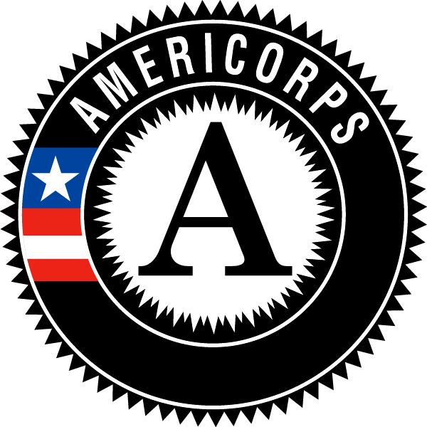
Americorps FAQs

Q: What are the requirements for being an Americorps Member?
A: In order to apply, you must be at least 18 years old, have a high school diploma or GED, and be eligible to work in the United States. During the term of service, members are required to complete 1700 hours of service over 11 months, participate in local/regional trainings, and adhere to the standards of conduct outlined in the Americorps contract.

Q: What do Americorps members do?
A: Americorps members wear many hats and perform a variety of tasks. All members will be focusing on the volunteer program at their assigned partner site. This involves recruiting, training, and supervising volunteers, fundraising for the programs, planning events, and assisting staff at their site. Members will work closely with their supervisor who serves as a mentor to the member. Site supervisors are responsible for contributing to the professional development aspect of Americorps service by teaching members new skills, and providing regular feedback throughout the year. More specific duties will vary based on the organization members serve with.

Q: How much interaction do we have with other members?
A: Every member in the Americorps VIP program is assigned to a partner site. This site is where the majority of time is spent. However, all members come together for training meetings at the Volunteer Center twice per month, participate in 3 National Days of Service together, and are welcome to volunteer at other sites when they have time. Additionally, members are free to spend personal time together and develop friendships with each other.

Q: What is the pay for Americorps service? Are there other benefits?
A: Members in the Santa Cruz Americorps VIP program receive a $14,000 living allowance paid in equal installments every two weeks over 11 months. In addition to this, members can opt in to receive full health care, CalFresh (EBT) food assistance of ~$200/month, a $5,730 education award, student loan forbearance, 170 hours of professional development training, and child care.

Q: Is Americorps like the Peace Corps?
A: Yes. AmeriCorps is often referred to as "the domestic Peace Corps." Both agencies are committed to service, and both offer challenging and rewarding full-time opportunities. Peace Corps assignments are all overseas, and AmeriCorps members serve only in the US. While Peace Corps Volunteers serve for two years, a stint in AmeriCorps usually lasts 10 months to one year. (Some AmeriCorps projects also offer part-time opportunities, and some AmeriCorps members serve more than one term of service.)

Q: What skills do I need to have?
A: Americorps is a professional development experience, so many of the skills will be learned or improved throughout the term. However, skills that are useful and will help your chances of being admitted are leadership experience, communication skills, project management, multi-tasking, and experience with non profits/volunteering, community outreach, recruitment, fundraising, and managing a team.

Q: How does loan deferment work? Does it account for interest?
A: Once accepted into the program, you can file a request with your loan holder with backing from your Americorps program. Deferment is only valid for student loans, and does not apply to debts like credit cards, car payments, etc. Interest will still be charged throughout the term, however you can also request a payment from the Americorps national organization to pay off interest at the end of your term.

Q: What can I use my education award for?
A: The education award can be used to pay off loans, or go towards furthering education including tuition, books, supplies (such as a laptop), or other trade schools (massage, scuba, etc). The education award is valid at all Title IV schools. If your school of choice is not a Title IV school, but will accept payment from the National Trust, you may use your award for any costs of attending.

Q: What if I’m done with school and have no loans? Can I get my education award in cash?
A: For the VIP program, no you may not.

Q: Does Americorps provide housing?
A: Some Americorps programs do provide housing, however this particular program does not.

Q: What have past members done after their term?
A: Some members are hired on as full time staff at their partner site or continue for a second Americorps term. Some continue their education in a Bachelors, Masters, or PhD program. Others move on to a completely different career field.

Q: How do I apply?
A: Send a resume to americorps@scvolunteercenter.org, or visit http://www.nationalservice.gov/programs/americorps/join-americorps and navigate through the search bar to “Americorps VIP: Volunteer Center of Santa Cruz County”

